

Pokémon Classification

Project

# Charles Christopher Hyland

# 450411920



# **Table of Content**

**Section 1: Data Understanding**

Section 1.1: Data Exploration

Section 1.2: Data Quality Verification

**Section 2: Data Preparation**

Section 2.1: Data Selection

Section 2.2: Data Preparation



# **Data Understanding**

## Data Description

**Data Description Report**

The data comes in as a tabular format, which contains 12 attributes.

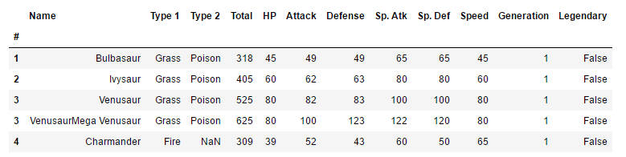

**Fig. 1 Snapshot of sample of data.**

Here, in a snapshot of the data, we can see it is organized in a table format. Furthermore, if a Pokémon does not have a second type, then NaN is used in place. The “Legendary” attribute return False if the Pokémon is not a legendary type Pokémon and returns True if it does.

The variables present in the data and its respective type is as follow:

|  |  |
| --- | --- |
| **Variable** | **Type** |
| Type 1 | String |
| Type 2 | String |
| Total | Numeric |
| HP | Numeric |
| Attack | Numeric |
| Defence | Numeric |
| Special Attack | Numeric |
| Special Defence | Numeric |
| Speed | Numeric |
| Generation | Numeric |
| Legendary | Boolean |

**Fig 2. List of variables**

The binary variable of Legendary will have to be converted into a numerical binary format (0 for False and 1 for True) to make data manipulation easier. Generation is coded as a numeric range from 1-6, where each number indicates a different region.

For a breakdown of what the different variables mean:

|  |  |
| --- | --- |
| **Variable** | **Type** |
| Type 1 | The primary “type” of Pokémon it is (e.g. fire, water). |
| Type 2 | The secondary “type” of Pokémon it is (e.g. fire, water). |
| Total | The summation of all other attributes pertaining to that Pokémon. |
| HP | How many health points the Pokémon has. |
| Attack | How many attack points the Pokémon has. |
| Defence | How many defence points the Pokémon has. |
| Special Attack | How many special attack points the Pokémon has. |
| Special Defence | How many special defence points the Pokémon has. |
| Speed | How many speed points the Pokémon has. |
| Generation | Which region does the Pokémon come from. |
| Legendary | Whether the Pokémon is a legendary Pokémon. |

**Fig. 3 Variable breakdown**

**Data Exploration Report**

The attributes that seem most promising from the data in terms of using to classify Pokémon are:

* Attack
* Defence
* Special Attack
* Special Defence
* Speed

The generation (the region in which the Pokémon comes from) of the Pokémon currently seems irrelevant. However, it may be the case that Pokémon of a certain type from a particular region, has a combination of features which differ to Pokémon of the same type in other regions.

To further subset the data, we can use a swarm plot to see a breakdown of the types of Pokémon and the their respective attributes.

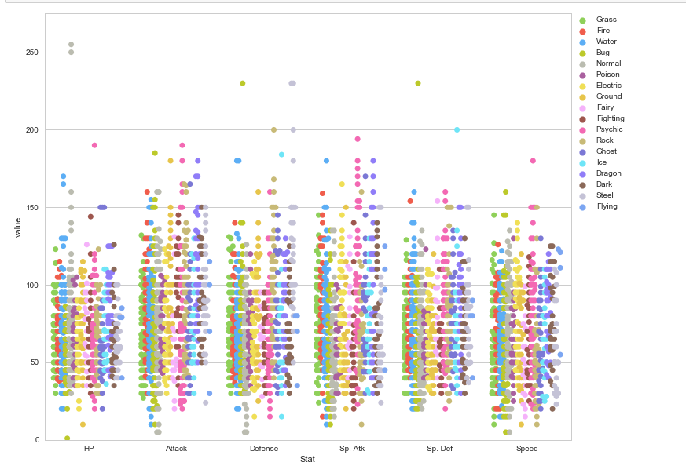Using a swarm plot will help with the initial visualisation of the data:

**Fig. 4 Swarm plot of attributes**

We can see that from this, it appears that from the distribution of Pokémon types, the majority of them posses around the similar attributes. Much more of an in depth analysis is needed to uncover the distribution of the Pokémon.



**Fig. 5 Overview of Pokémon attributes**

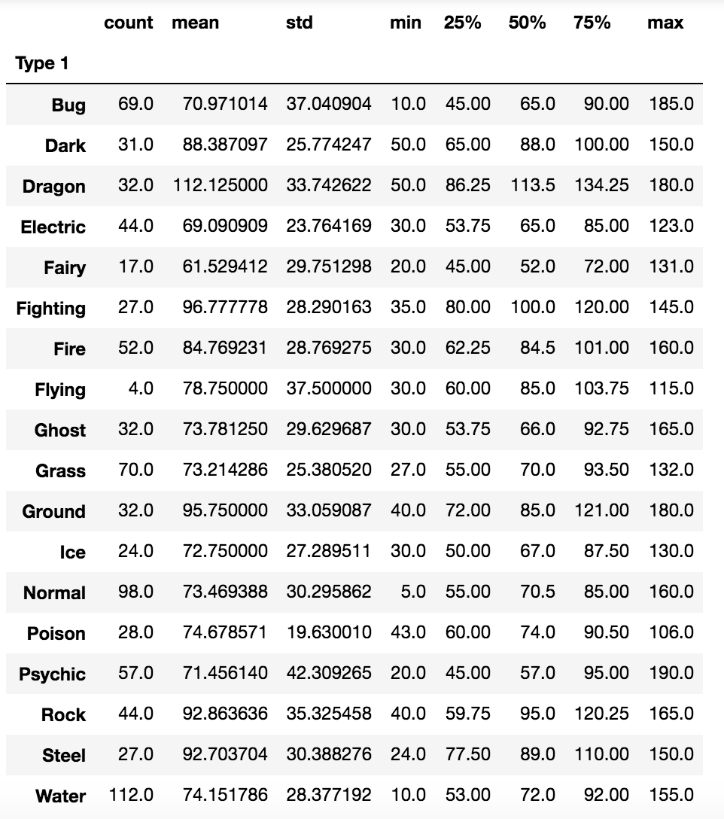

**Fig. 6 Attack attributes**

From the figure 5, that when aggregating all Pokémon types together, there are noticeable outliers for each attribute. From that, when analysing the attack attribute via subsetting the Pokémon by their types, we obtain figure 6. From this, it is evident that Dragon Type Pokémon has the highest attack attribute whilst fairy type Pokémon has the lowest attack attribute. There is a difference of 51 attack points between the means of these 2 Pokémon types, therefore suggesting there is a statistical difference in attack attributes among Pokémon types. We can then repeat the breakdown of Pokémon types for the other attributes as seen from figure 7-10.

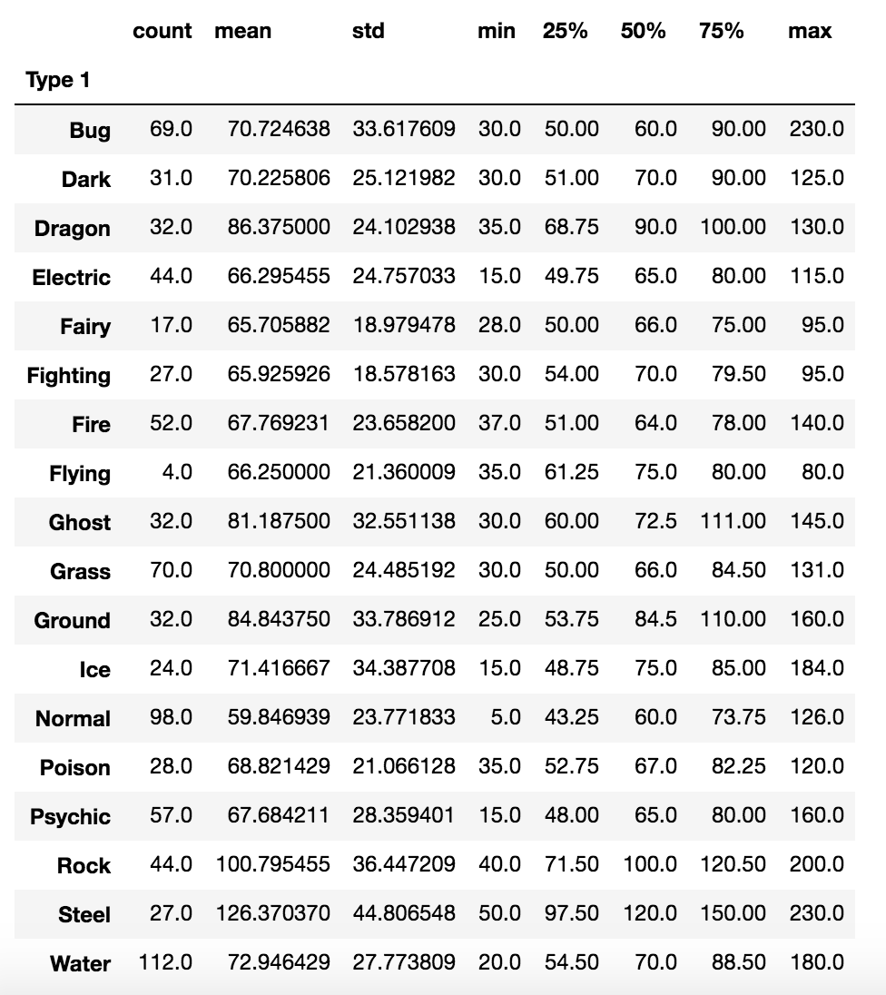

**Fig. 7 Defense**

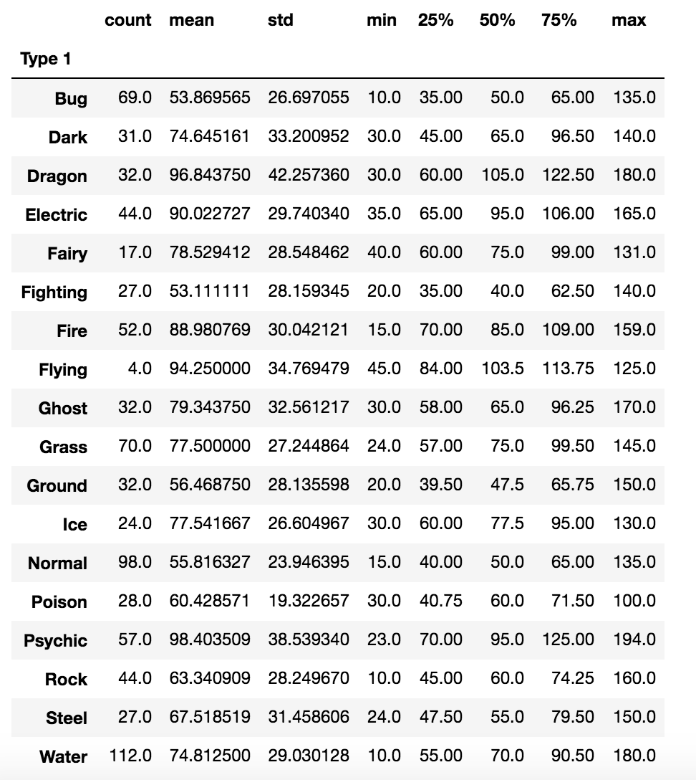

**Fig. 8 Special Attack**

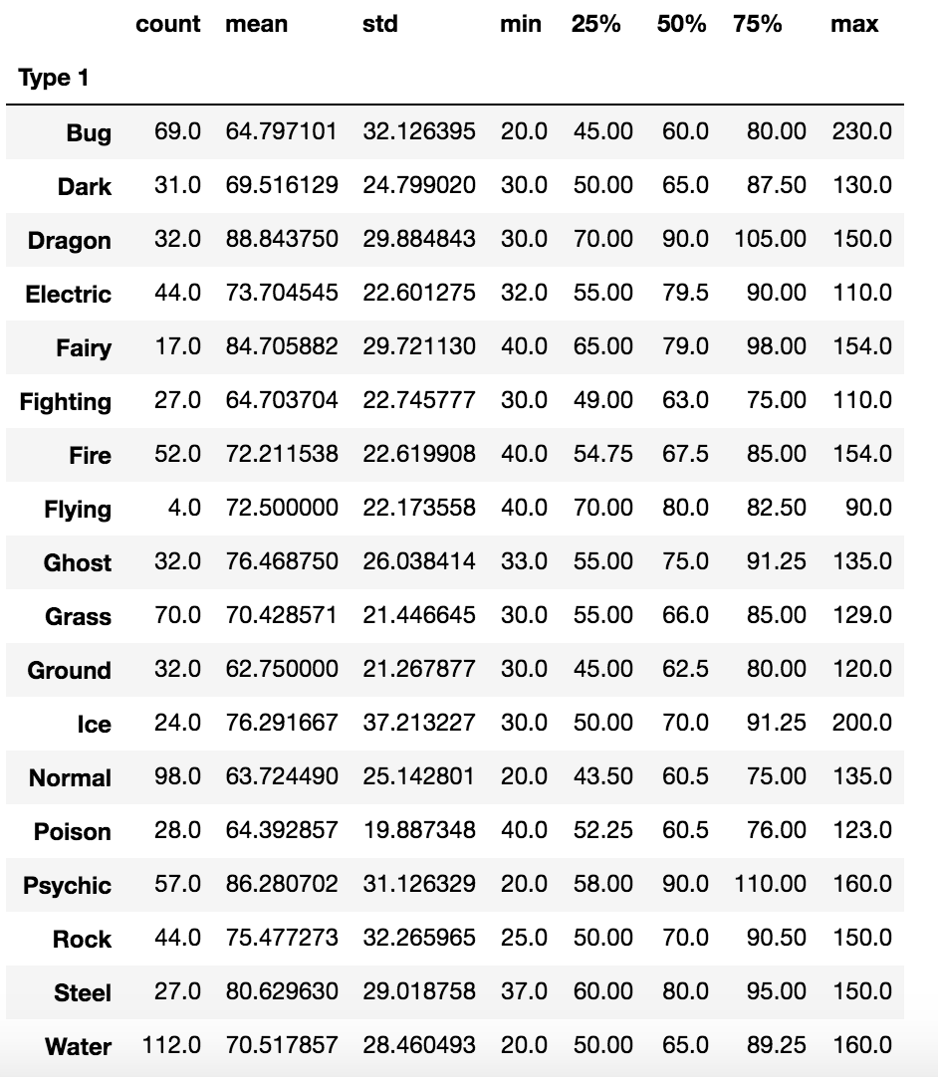

**Fig. 9 Special Defense**

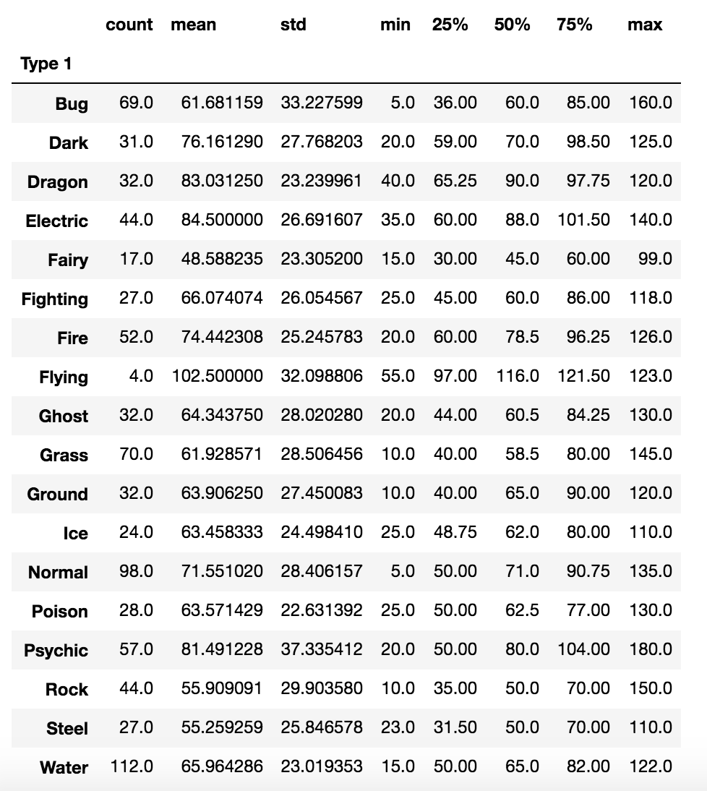

**Fig. 10 Speed**

From this, it is evident that there are noticeable differences between Pokémon types with regards to their attributes. This confirms out initial hypothesis that there are noticeable differences between the Pokémon types and their attributes, therefore allowing our process of classifying and identifying Pokémon based on their type feasible.

When splitting the data up by the type of Pokémon and summarizing the data based on certain variables, a few noticeable results appeared:

|  |  |  |  |  |
| --- | --- | --- | --- | --- |
| **Variable** | **Maximum** | **Type** | **Minimum** | **Type** |
| Attack | 112.13 | Dragon | 70.97 | Bug |
| Defence | 126.37 | Steel | 65.71 | Fairy |
| Special Attack | 96.84 | Dragon | 53.87 | Bug |
| Special Defence | 88.84 | Dragon | 62.75 | Ground |
| Speed | 102.5 | Flying | 55.26 | Steel |

From this, it appears that certain Pokémon types are associated with certain characteristics and due to the discrepancies between the maximum and minimum value for each type, it is worthwhile to assume that different types of Pokémon have unique attributes associated with them. From this, we are able to proceed with the business question and makes it worthwhile to further examine this trend.

Additionally, we can see the count of each primary type of a Pokémon through a frequency table.

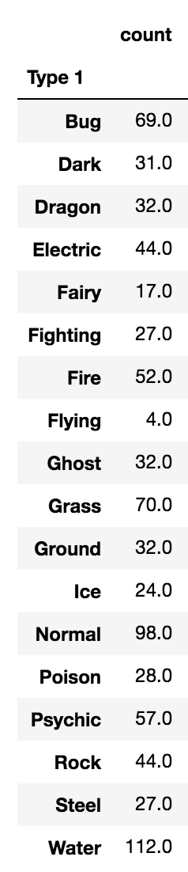

**Fig. 11 Frequency of Pokémon by type 1**



**Fig. 12 Percentage breakdown of Pokémon types**

From this, it is evident that water type Pokémon are the most frequent Pokémon with over 112 instances whilst normal type Pokémon is the second most frequent. Additionally primary flying type Pokémon appears to be the rarest Pokémon. This was an unexpected result as there were many cases of Pokémon posessing wings and “flying-type” attack moves such as fly. Further investigation into this led us to then analyse that in addition to the primary type of a Pokémon, does the Pokémon also posses a secondary type? The result from this question is seen in the next table:

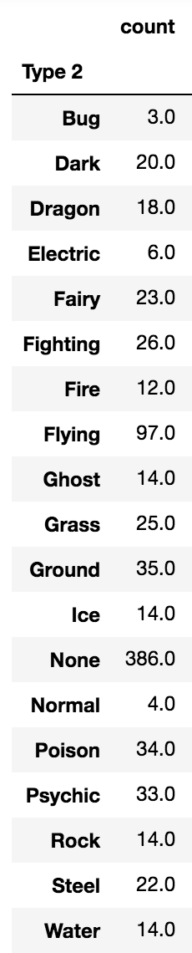

**Fig. 13 Frequency of Pokémon by type 2**

Here, flying type is the most common Pokémon’s secondary type, excluding the fact that most Pokémon seem to not have a secondary type. This solves our earlier conundrum with regards to the apparent infrequency of flying type Pokémon. We can then formulate that most Pokémon tend to be of a primary type with the added secondary type of being able to fly.

Aggregating the Pokémon types again, we see the following results:

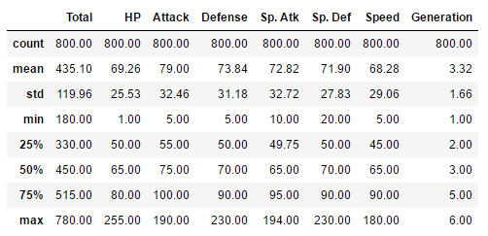

**Fig 14. Summary statistics of the data**

We noted that the mean is greater than the median for the attributes of the Pokémon, thereby suggesting that the distribution of such variables are positively or right skewed.

Resultantly, through this exploration, there is no need to alter the data-mining goals.

## Data Verification Report

**Data Quality Report**

As we were given this dataset by Professor Oak himself, it is imperative to verify the quality of the data we were given.

Missing data

Any missing value issues in the data was rectified as follows:

1. Find out the type of Pokémon it is.
2. Check whether the distribution of the other observations of the variable was skewed or not.
   1. If the data was skewed
      1. Calculate the median of the attribute that the missing value belongs to from the rest of the Pokémon of the same type.
      2. Use the median to replace the missing value.
   2. If the data was normally distributed:
      1. Calculate the mean of the attribute that the missing value belongs to from the rest of the Pokémon of the same type.
      2. Use the mean to replace the missing value.

It is worth acknowledging the flaws in this methodology, yet it is sufficient for the task at hand. However, there were very few observations missing in the dataset.

Data error

There were no typographical errors with regards to the data as it has been cross validated by Professor Oak himself and the rest of his Pokémon research assistant.

Measurement errors

There were no measurement errors with regards to the data as all attributes were recorded on the same scale.

Coding inconsistencies

There were no coding inconsistencies between variables types.

Bad metadata

The Generation column is a misleading term and therefore, it is proposed that region would be a better indicator. The dataset will be recoded whereby we transform each generation field with the respective region of the Pokémon. This is dealt with later on in the data preparation stage.

# Data Preparation

**Data Selection**

Due to the small number of attributes, we do not remove any features and furthermore, due to no inconsistencies in the observations, we retain all observations. Furthermore, due to the low number of features compared to the number of observations, we do not run into the curse of dimensionality. Therefore, we select all Pokémon to be examined and keep all the current features in the original dataset so as to ensure that we do not lose any important information. We would like to retain as much information as possible in order to assist our classification efforts. Currently, from the data exploration phase, there are noticeable discrepancies between Pokémon types with regards to all the attributes and therefore, keeping the attributes will assist our algorithm tremendously.

**Data Cleaning**

As noted in the data exploration phase, there were no apparent issues and therefore need to clean the data with regards to the following criteria:

* No missing data
* No data errors found
* No apparent measurement errors

**Data Construction**

As mentioned from the data exploration phase, there is a need to alter the categorical column of generation as it currently suggests there is ordinality for the generation column, which again does not make sense as a Pokémon from generation 5 is not “better” than a Pokémon from generation 1. Therefore, we need to encode dummy variables into the model indicating which generation is the Pokémon a part of and then remove the original generation column. The results of such actions looks as follows:

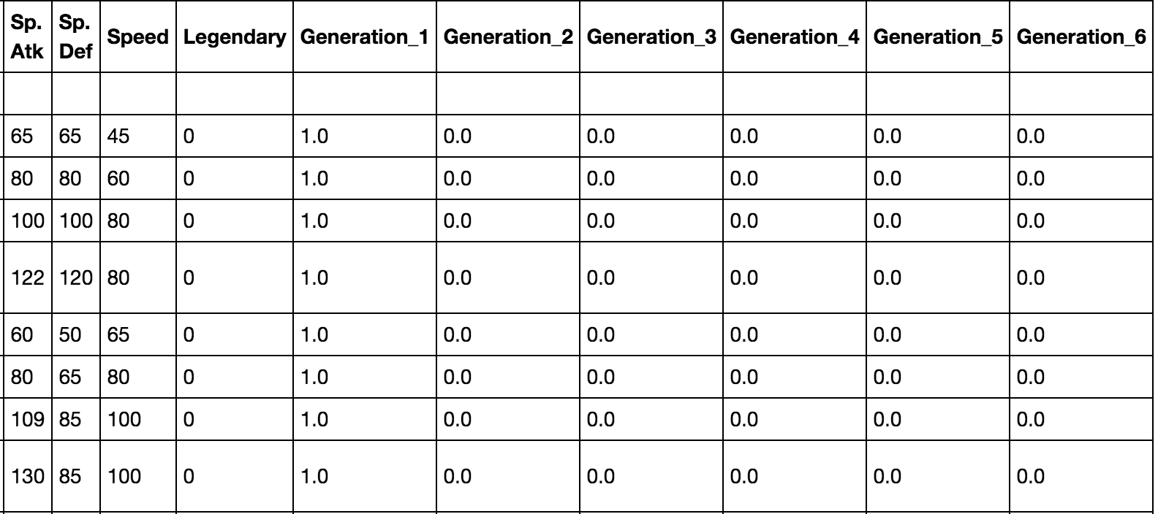

**Fig. 15 Newly constructed features**

The construction of such binary variables now allows the algorithm to identify which region does a particular Pokémon originate from and by including only 5 dummy variables, we do not fall into the dummy variable trap.

Furthermore, for the Type 1 and Type 2 column, these categorical variables were converted into dummy variables for ease of data analysis. A preview of this can be seen here:

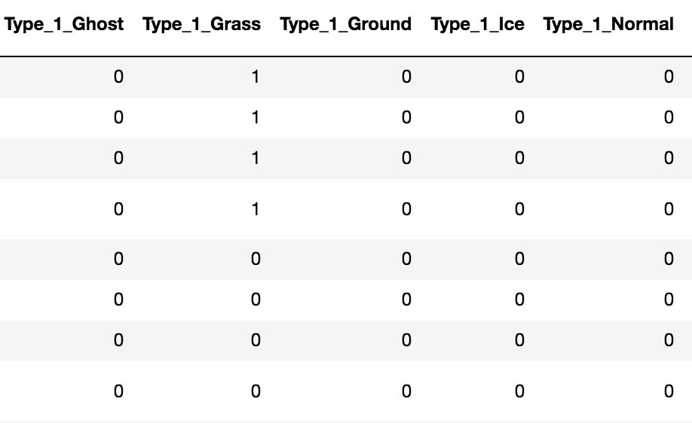

**Fig. 16 Newly constructed features**

No further data was altered or created.

**Data Integration**

The data initially came from existing data scraped over numerous websites via APIs. Fortunately for us, the dataset provided has already been merged and integrated regarding the Pokémon from the different regions. With this in mind, there is no need for any work regarding the integration of the dataset.

**Data Formatting**

Due to the nature of the data being a cross-sectional set, the ordering for the cross-sectional data does not matter. Furthermore, the algorithms and models that will be applied to the dataset also does not require any formatting to the dataset. However, any need for standardisation of the dataset will be done accordingly should the need for it arise. Therefore, no work was done on formatting the data.

**Dataset Description**

Amount of data

Currently, there are 800 observations from a cross-sectional dataset. From this it appears that the data allows us to draw generalizable conclusions and also assists us in making accurate predictions. However, a possible issue is that there are not many attributes. This may be a problem as our predictions may suffer from omitted variable bias and that important predictors we could be using are not present in the data.

Value Types

An updated table of the types of variables now present is as follow:

|  |  |
| --- | --- |
| **Variable** | **Type** |
| Type 1 | String |
| Type 2 | String |
| Total | Numeric |
| HP | Numeric |
| Attack | Numeric |
| Defence | Numeric |
| Special Attack | Numeric |
| Special Defence | Numeric |
| Speed | Numeric |
| Generation_1 | Numeric |
| Generation_2 | Boolean |
| Generation_3 | Boolean |
| Generation_4 | Boolean |
| Generation_5 | Boolean |
| Legendary | Boolean |

**Fig. 17 Updated variable table**

Coding Schemes

The only worthwhile coding scheme to note is the fact that 1 represents true and 0 represent false for the dummy variables present in the dataset.